***Images and colors are NOT an exact representation of final product due to screen resolution***
Price Quote:
*This quote is good for 7 Days from this signed proof
Quantity: Quantity Discount:
Design Name:
Shirt Color: Navy
Address: |  |  | from any mistakes or errors on products brought to us for decoration. If it is our mistake we will replace the product with something we have in-stock at the time.
City: | State: | Zip: | This custom quote is valid for 7 days from the date signed below.
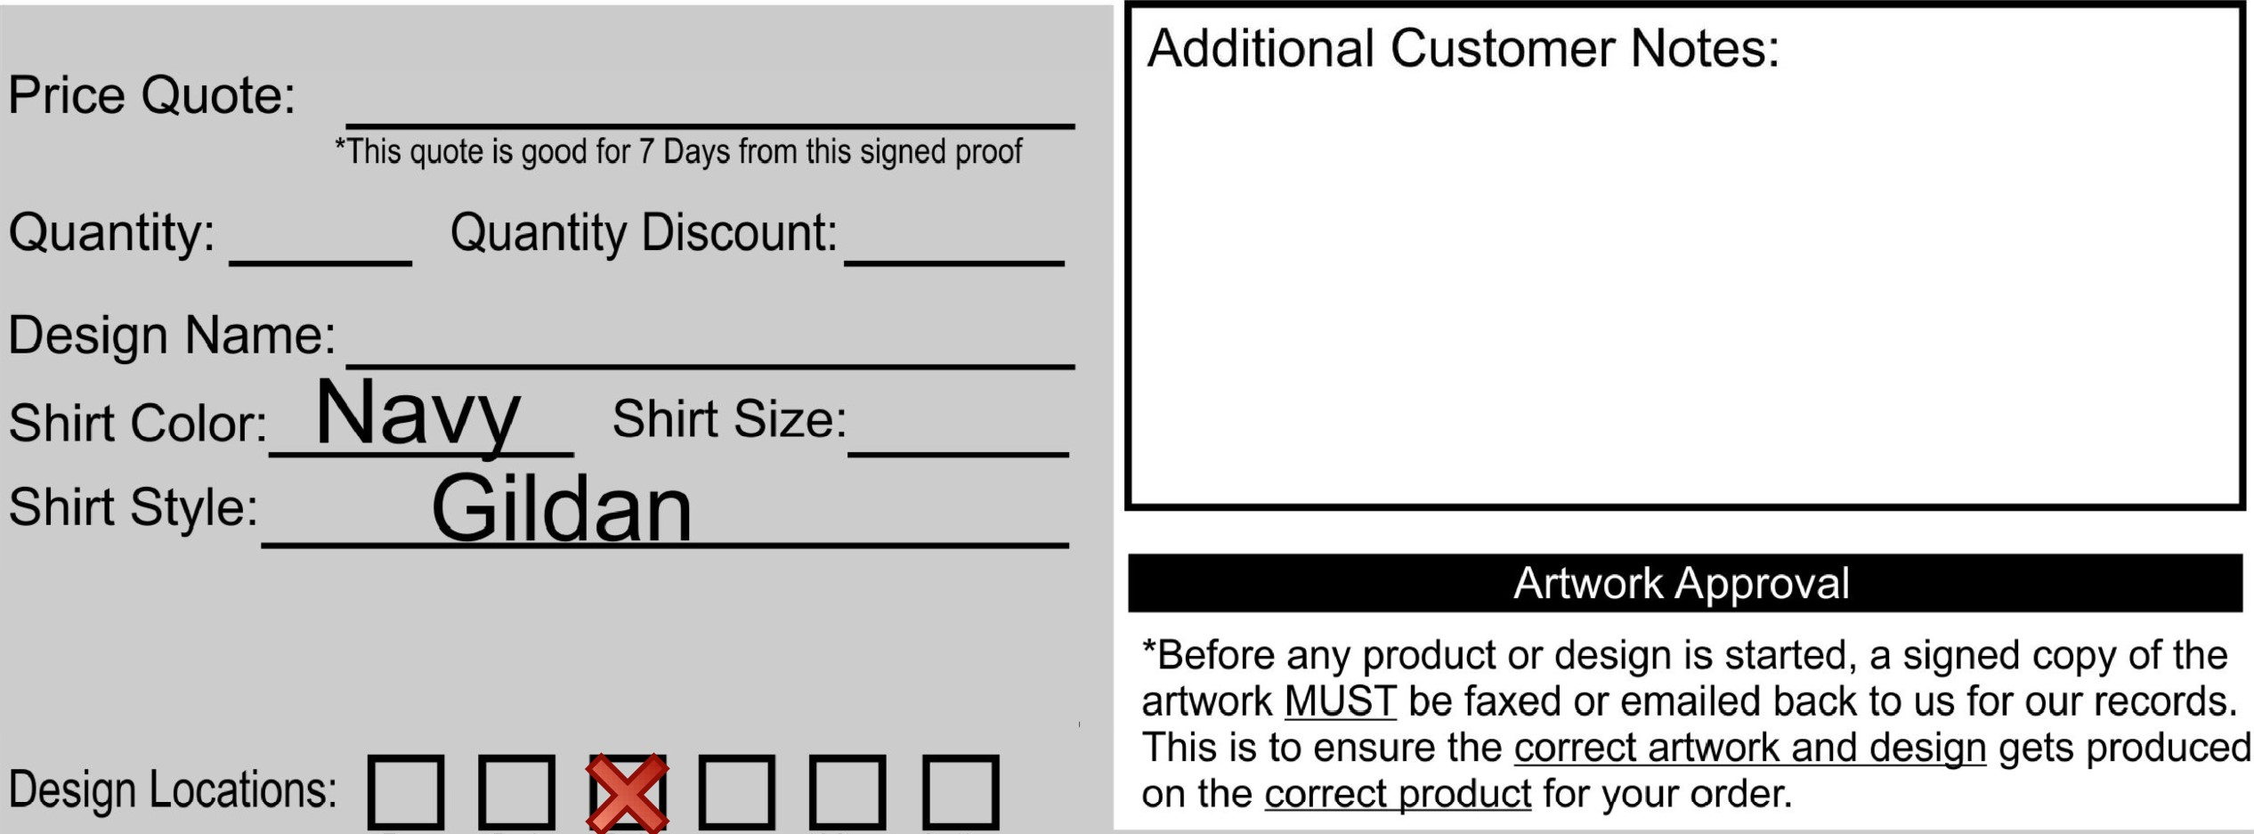
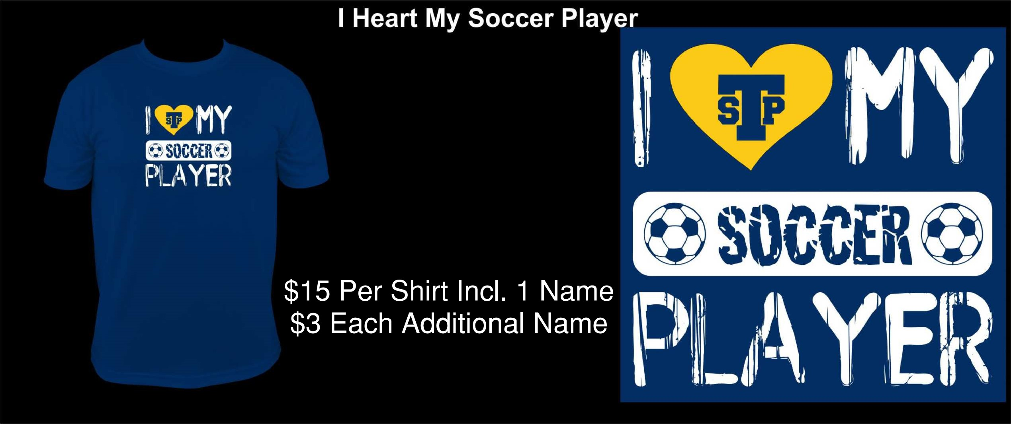
Shirt Style:
Front
Back
Both
Rt
Sleeve
Lft
Sleeve
See
Notes
Additional
Names:
***Typical turnaround time for a custom design is 7-14 business days from payment completion and signed approval is received (plus shipping time)***

Customer Information Name:
***By signing below you are agreeing that all information, colors, and spelling Address: on your order form is correct and to your approval. You are also waiving us

Contact #:

Email:
Signature Date

